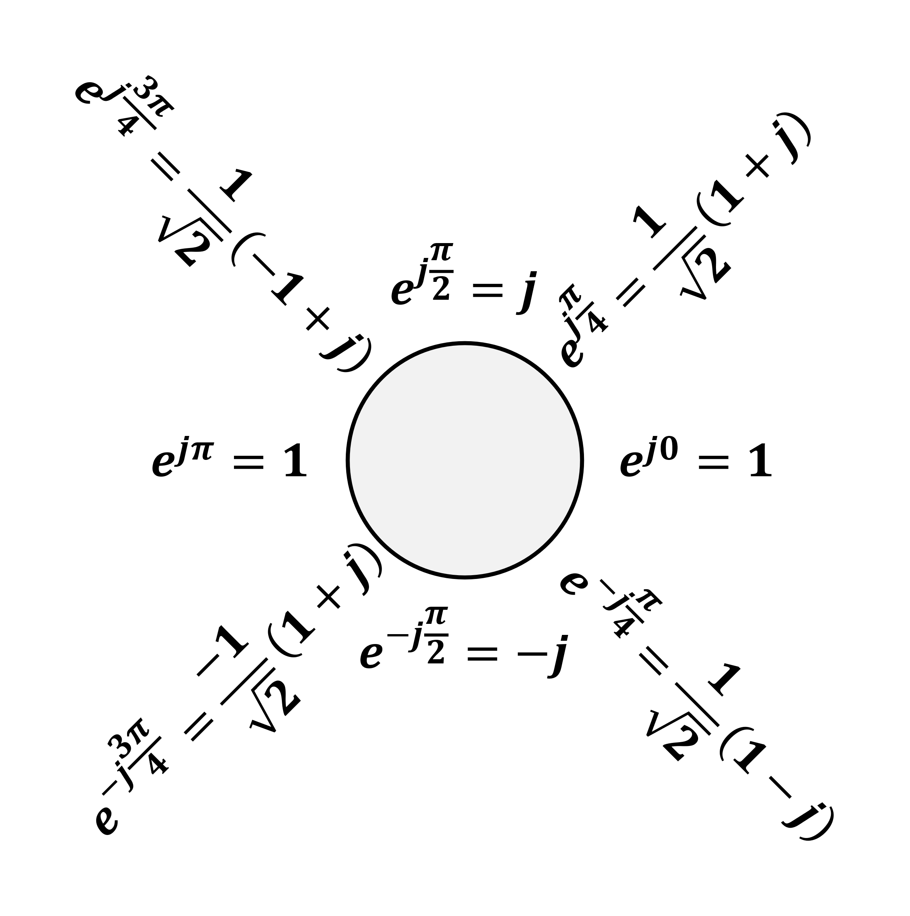

**Other Transform Pairs**

$u_{n}\left(t\right)=\frac{d^{n}}{dt^{n}}δ\left(t\right)\underset{↔}{L}s^{n}, u^{-n}\left(t\right)=\frac{1}{s^{n}}$

$e^{-at}\cos{ω_{0}t}u(t)\underset{↔}{L}\frac{s+a}{{\left(s+a\right)}^{2}+ω_{0}^{2}}$

$e^{-at}\sin{ω_{0}t}u\left(t\right)\underset{↔}{L}\frac{ω_{0}}{{\left(s+a\right)}^{2}+ω_{0}^{2}}$

${\left(\frac{\sin{t}}{πt}\right)}^{2}\underset{↔}{F}$ 三角形底 $-2$ 到 $2$，高 $\frac{1}{π}$

**Hilbert Transform**

$$\frac{1}{πt}\underset{↔}{F}-j·\operatorname{sign}{ω},\cos{ω_{0}t}\underset{→}{h\left(t\right)}\sin{ω_{0}t}$$

**Quick Reference Checklist快速检查单**

|  |  |  |  |
| --- | --- | --- | --- |
| **Signal** | **Transform** | **ROC** | **Pole** |
|  |  |  |  |
|  |  |  |  |
|  |  |  |  |
|  |  |  |  |
|  |  |  |  |
|  |  |  |  |
|  |  |  |  |
|  |  |  |  |
|  |  |  |  |
|  |  |  |  |

**和差化积公式与积化和差公式**

$\sin{α}+\sin{β}=2\sin{\frac{α+β}{2}}\cos{\frac{α-β}{2}}$ $\sin{α}-\sin{β}=2\cos{\frac{α+β}{2}}\sin{\frac{α-β}{2}}$ $\cos{α}+\cos{β}=2\cos{\frac{α+β}{2}}\cos{\frac{α-β}{2}}$ $\cos{α}-\cos{β}=-2\sin{\frac{α+β}{2}}\sin{\frac{α-β}{2}}$ $\sin{α}\cos{β}=\frac{1}{2}\left[\sin\left(α+β\right)+\sin\left(α-β\right)\right]$ $\cos{α}\sin{β}=\frac{1}{2}\left[\sin\left(α+β\right)-\sin\left(α-β\right)\right]$ $\cos{α}\cos{β}=\frac{1}{2}\left[\cos\left(α+β\right)+\cos\left(α-β\right)\right]$ $\sin{α}\sin{β}=-\frac{1}{2}\left[\cos\left(α+β\right)-\cos\left(α-β\right)\right]$

**Even and odd decomposition**

$$\operatorname{Ev}\left\{x\left[t\right]\right\}=\frac{1}{2}\left\{x\left(t\right)+x\left(-t\right)\right\} \\ \operatorname{Od}\left\{x\left[t\right]\right\}=\frac{1}{2}\left\{x\left(t\right)-x\left(-t\right)\right\}$$

奇分解围绕原点旋转除2，偶分解围绕y轴变换除2

**等比数列**

通项公式： $a_{n}=a_{1}q^{n-1}$

两项关系： $a_{n}=a_{m}q^{n-m}$

求和公式： $S_{n}=a_{1}\frac{a-q^{n}}{1-q}=\frac{a_{1}-a_{n}q}{1-q}$

**Sinc Function**

$$\operatorname{sinc}{θ}=\frac{\sin{πθ}}{πθ}$$

**Laplace Transform拉普拉斯变换**

$$X\left(s\right)≜\int_{-∞}^{∞}{x\left(t\right)e^{-st}dt} \\ x\left(t\right)=\frac{1}{2πj}\int_{σ-j∞}^{σ+j∞}{X\left(s\right)e^{st}ds}$$

**时域频域卷积相乘关系**

$$y\left(t\right)=h\left(t\right)*x\left(t\right)\underset{↔}{F}Y\left(jω\right)=H\left(jω\right)X\left(jω\right)$$

$$r\left(t\right)=s\left(t\right)p\left(t\right)\underset{↔}{F}R\left(jω\right)=\frac{1}{2π}\int_{-∞}^{∞}{S\left(jθ\right)P\left(j\left(ω-θ\right)\right)dθ}$$

**Fourier Series傅里叶级数**

|  |  |
| --- | --- |
| $$x\left(t\right)=e^{st}\underset{→}{ LTI }y\left(t\right)=H\left(s\right)e^{st}$$ $$\sum_{k}{a_{k}e^{s_{k}t}}\underset{→}{ LTI }\sum_{k}{a_{k}H\left(s_{k}\right)e^{s_{k}t}}$$ | $$x\left[n\right]z^{n}\underset{→}{ LTI }y\left[n\right]=H\left(z\right)z^{n}$$ $$\sum_{k}{a_{k}z_{k}^{n}}\underset{→}{ LTI }\sum_{k}{a_{k}H\left(z_{k}\right)z_{k}^{n}}$$ |
| $$H\left(s\right)=\int_{-∞}^{∞}{h\left(t\right)e^{-st}}dt \\ H\left(jω\right)=\int_{-∞}^{∞}{h\left(t\right)e^{-jωt}}dt$$ | $$H\left(z\right)=\sum_{k=-∞}^{∞}{h\left[k\right]z^{-k}} \\ H\left(e^{jω}\right)=\sum_{n=-∞}^{∞}{h\left[n\right]e^{-jωn}}$$ |
| $$x\left(t\right)=\sum_{k=-∞}^{∞}{a_{k}e^{jkω_{0}t}}$$ $$a_{k}=\frac{1}{T}\int_{T}{x\left(t\right)e^{-jkω_{0}t}}dt$$ | $$x\left[n\right]=\sum_{k=<N>}{a_{k}e^{jkω_{0}n}}$$ $$a_{k}=\frac{1}{N}\sum_{n=<N>}{x\left[n\right]e^{-jkω_{0}n}}$$ |

**采样与恢复的过程**

$$p\left(t\right)=\sum_{n=-∞}^{∞}{δ\left(t-nT\right)}\underset{↔}{F}\frac{2π}{T}\sum_{k=-∞}^{∞}{δ\left(ω-k\frac{2π}{T}\right)}=ω_{s}\sum_{k=-∞}^{∞}{δ\left(ω-kω_{s}\right)} \\ p\left(t\right)x\left(t\right)\underset{↔}{F}\frac{1}{2π}X\left(jω\right)*P\left(jω\right)=\frac{ω_{s}}{2π}\sum_{k=-∞}^{∞}{X\left(j\left(ω-kω_{s}\right)\right)}=\frac{1}{T}\sum_{k=-∞}^{∞}{X\left(j\left(ω-kω_{s}\right)\right)}$$

采样后信号的频率响应幅值变为 $1/T$ 倍，因此恢复信号时要通过一个增益为 $T$ 的BPF，BPF的截止频率最好为 $\frac{ω_{s}}{2}$

**Z变换特殊峰的判断**

信号为正，零点有峰

信号为负，无穷有峰

**Nyquist Sampling Theorem**

Let $x\left(t\right)$ be a band-limited signal within $±ω_{M}$, then $x\left(t\right)$ is uniquely determined by its samples $x\left(nT\right)$ if $ω_{s}>2ω_{M}$, where $ω_{s}=\frac{2π}{T}$.

Nyquist rate: $2ω_{M}$

**Convolution卷积**

$$y\left[n\right]=\sum_{k=-∞}^{∞}{x\left[k\right]h\left[n-k\right]}=\sum_{k=-∞}^{∞}{x\left[n-k\right]h\left[k\right]} \\ y\left(t\right)=\int_{-∞}^{+∞}{x\left(τ\right)h\left(t-τ\right)dτ}\int_{-∞}^{+∞}{x\left(t-τ\right)h\left(τ\right)dτ}$$

一个函数的 $t$ 换成 $τ$，另一个函数的 $t$ 换成 $t-τ$；如果结果以原点为界，记得写成 $u\left[n\right]u\left(t\right)$ 的形式； $x\left(τ\right)$ 的图像正常， $h\left(t-τ\right)$ 的图像关于 $y$ 轴翻转后，原点为 $t$

**Euler’s formula欧拉公式**

$$e^{jθ}=\cos{θ}+j\sin{θ} \\ \cos{θ}=\frac{e^{jθ}+e^{-jθ}}{2} \\ \sin{θ}=\frac{e^{jθ}-e^{-jθ}}{2j}$$

**诱导公式**

$\sin\left(2kπ+α\right)=\sin{α}$ $\cos\left(2kπ+α\right)=\cos{α}$ $\sin\left(-α\right)=-\sin{α}$ $\cos\left(-α\right)=\cos{α}$ $\sin\left(π-α\right)=\sin{α}$ $\cos\left(π-α\right)=-\cos{α}$ $\sin\left(π+α\right)=-\sin{α}$ $\cos\left(π+α\right)=-\cos{α}$ $\sin\left(\frac{π}{2}-α\right)=\cos{α}$ $\cos\left(\frac{π}{2}-α\right)=\sin{α}$ $\sin\left(\frac{π}{2}+α\right)=\cos{α}$ $\cos\left(\frac{π}{2}+α\right)=-\sin{α}$ $\operatorname{tg}\left(kπ+α\right)=\operatorname{tg}{α}$ $\operatorname{tg}\left(-α\right)=-\operatorname{tg}{α}$ $\operatorname{tg}\left(π-α\right)=-\operatorname{tg}{α}$ $\operatorname{tg}\left(π+α\right)=\operatorname{tg}{α}$ $\operatorname{tg}\left(\frac{π}{2}-α\right)=\operatorname{ctg}{α}$ $\operatorname{tg}\left(\frac{π}{2}+α\right)=-\operatorname{ctg}{α}$

**Z-Transform Z变换**

$$X\left(z\right)≜\sum_{n=-∞}^{∞}{x\left[n\right]z^{-n}} \\ x\left[n\right]=\frac{1}{2πj}\oint{X\left(z\right)z^{n-1}dz}$$

**Fourier Transform傅里叶变换**

$$X\left(jω\right)=\int_{-∞}^{∞}{x\left(t\right)e^{-jωt}dt} \\ X\left(jω\right)=\sum_{k=-∞}^{∞}{2πa_{k}δ\left(ω-kω_{0}\right)} \\ x\left(t\right)=\frac{1}{2π}\int_{-∞}^{∞}{X\left(jω\right)e^{jωt}dω}$$

**System Properties (Laplace Transform)**

|  |  |
| --- | --- |
| Causality | ROC is a right-half plane |
| Causality  (Rational $H\left(s\right)$) | ROC is the right-half plane to the right of the rightmost pole |
| Anticausality | ROC is a left-half plane (to the left of the leftmost pole) |
| Stability | ROC includes the entire $jω$-axis |

Causal LTI system with rational $H\left(s\right)$: all poles lie in the left-half of the s-plane

**System Properties (Z-Transform)**

|  |  |
| --- | --- |
| Causality | ROC is the exterior of a circle including infinity |
| Causality  (Rational $H\left(s\right)$) | ROC is the exterior of a circle outside the outermost pole + 分子z阶数不能比分母大 |
| Stability | ROC includes the unit circle |

Causal LTI system with rational $H\left(s\right)$: all poles lies inside the unit circle + 分子z阶数不能比分母大

**Basic BD Pairs**

|  |  |
| --- | --- |
| $$H\left(s\right)=\frac{1}{s+3}$$ | $$H\left(z\right)=\frac{1}{1-\frac{1}{4}z^{-1}}$$ |
|  |  |
| $$H\left(s\right)=\frac{s^{2}-s-6}{s^{2}+2s+1}$$ | $$H\left(z\right)=\frac{1-\frac{7}{4}z^{-1}-\frac{1}{2}z^{-2}}{1+\frac{1}{4}z^{-1}-\frac{1}{8}z^{-2}}$$ |
|  |  |